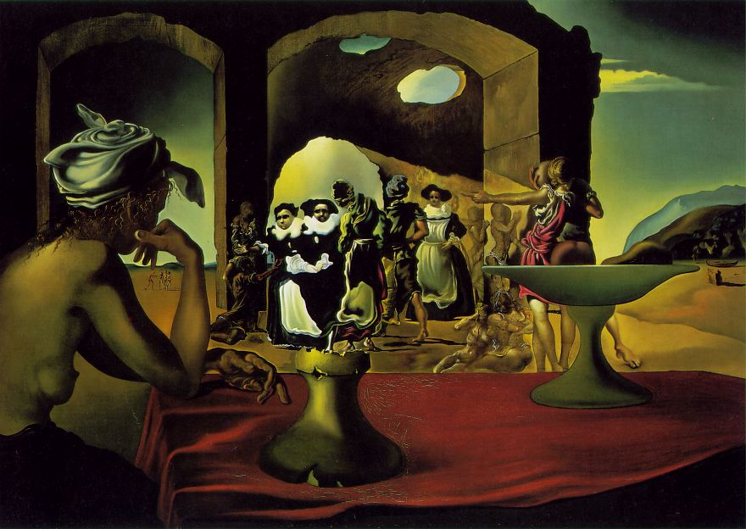
Βλέπω.................................................................................................................................

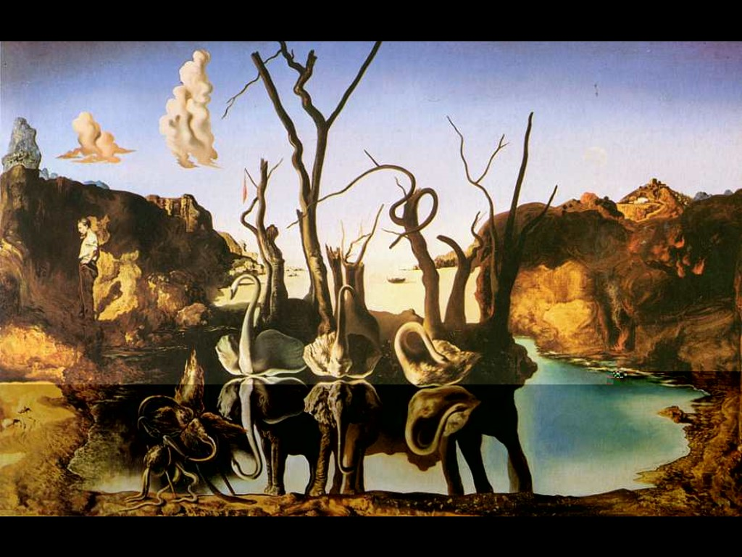
Βλέπω........................................................................................................................................

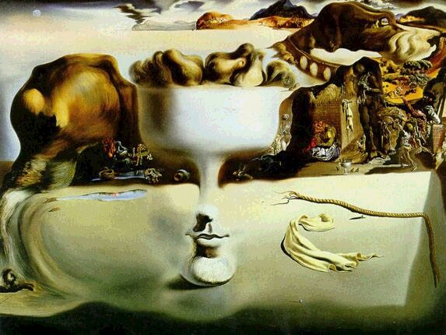

Βλέπω.................................................................................................................................................

